CHAPTER 1
INTRODUCTION
Presently, the United States is the most technologically advanced country in the area of telecommunications with about; 126 million phone lines, 7.5 million cellular phone users, 5 thousand AM radio broadcast stations, 5 thousand FM radio stations, 1 thousand television broadcast stations, 9 thousand cable television systems, 530 million radios, 193 million television sets, 24 ocean cables, and scores of satellite facilities! This is truly an "Information Age" and sometimes, you need to look at where we've been
in order to see the future more clearly!
a) Information
“Information is a term with many meanings depending on context, but is as a rule closely related to such concepts as meaning, knowledge, instruction, communication, representation, and mental stimulus”
b) Information Transfer
A co-ordinate sequence of user and telecommunications system actions that cause information present at a source user to become present at a destination user. Note: An information-transfer transaction usually consists of three consecutive phases called the access phase, the information-transfer phase, and the disengagement phase.
c) Broadcast
A term to describe communication where a piece of information is sent or transmitted from one point to all other points. There is just one sender, but the information is 3 simultaneously sent to all connected receivers. In networking, a distinction is made between broadcasting and multicasting. Broadcasting sends a message to everyone on the network whereas multicasting sends a message to a select list of recipients. One of the most common examples is broadcast through a cellular network service. This serves multiple end users at different locations in a simulcast fashion. Practically every cellular system has some kind of broadcast mechanism. This can be used directly for distributing information to multiple mobiles, commonly, for example in a mobile telephony system, the most important use of broadcast information is to set up channels for one to one communication between the mobile Trans-receiver and the base station. This is called paging. The details of the process of paging vary somewhat from network to network, but normally we know a limited number of cells where the phone is located (this group of cells is called a location area in the GSM system or Routing Area in UMTS). Paging takes place by sending the broadcast message on all of those cells. Today, interaction with digital displays is a deskbound or device-dependent experience. However, developments in display and information sharing technologies may enable a new form of interaction with digital media: ‘ubiquitous computing’. In ubiquitous computing, the physical location of data and processing power is not apparent to the user. Rather, information is made available to the user in a transparent and contextually relevant manner. A single display device restricts the repertoire of Interactions between the user and digital media, so ubiquitous computing requires displays wherever the user might need one – in appliances, tabletops public transport, walls, etc. This project aims at integrating the expansiveness of a wireless cellular network and the ease of information transfer through the SMS with the coverage of public display boards. It is thereby a modest effort to realize the complete potential of public display boards in instantaneous information broadcast.

CHAPTER 2
DESIGN OVERVIEW
2.1. Block diagram
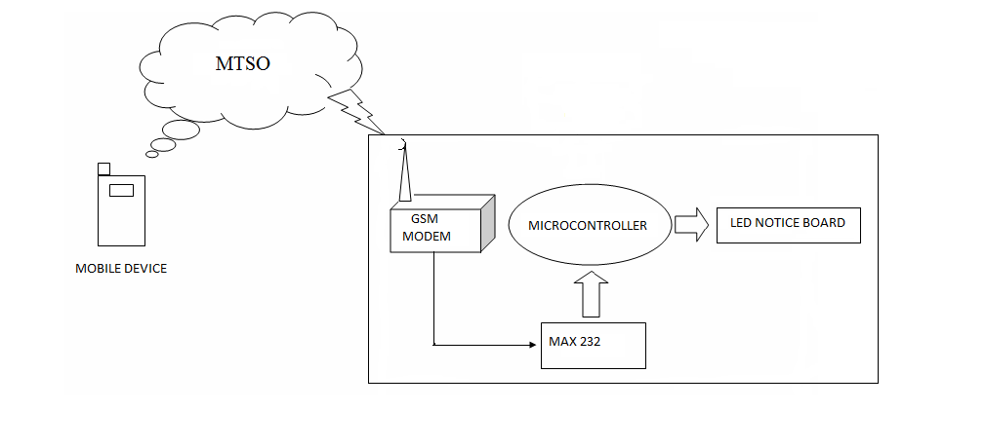
As explained in the introduction chapter, the realization of complete potential of the display boards and the wireless medium in information transfer is the major issue that the following thesis of the following project deals with.

Figure 2.1. Design Overview

As we see in the above figure, there are at least three interfacing circuits, MAX-232 with microcontroller, LED display with microcontroller, and MAX-232 with GSM MODEM. The display boards used commercially can be as follows:

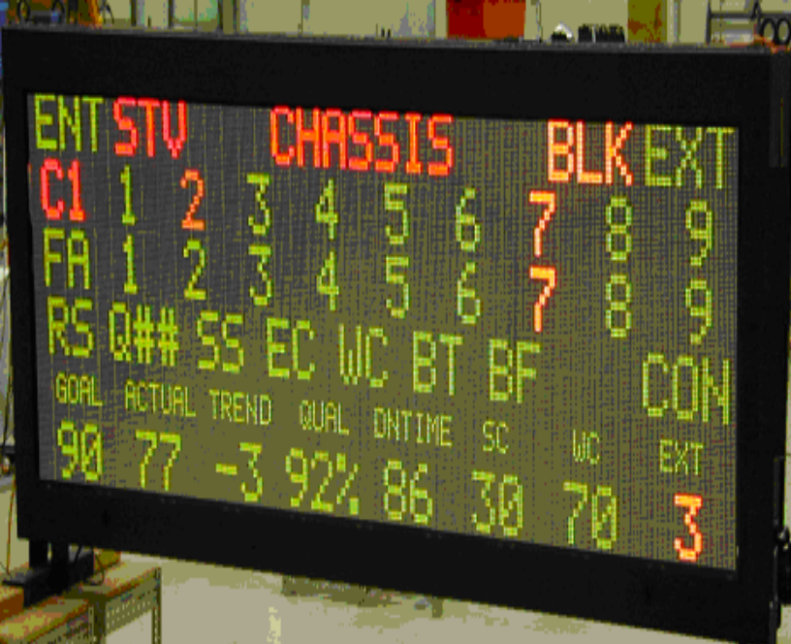
Figure 2.2 commercially used display boards
The input requirement for such kind of display boards are 120/240 VAC 50//60 Hz with Internal circuit breaker sized per sign layout. The display boards are usually huge in size and can’t be used for simulation purpose. So Small LED displays are used for testing.
It is not a hidden fact that interfacing a MODEM with a normal PC is quite easy with the help of the AT commands sent to it from the Hyper Terminal window. But we must take into account the fact that the MODEM requires a wired connection at one end and wireless at the other. Dedicating a general purpose computer at each and every site of the display boards, although makes the task a lot easier but is too expensive to be a possibility. Hence we employ ATMEGA16 microcontroller. The complexity of coding substantially increases, but once programmed the module works at its robust best since it is a dedicated embedded system and not a general purpose computer. The design procedure involves identifying and assembling all the required hardware and ensuring fail safe interfacing between all the components. Then we have the coding process which has to take care of the delays between two successive transmissions and most importantly the validation of the sender’s number. The number of valid mobile numbers can be more than one. The limiting constraint is the RAM of the microcontroller rather than the coding complexity.
2.2 Operation flow

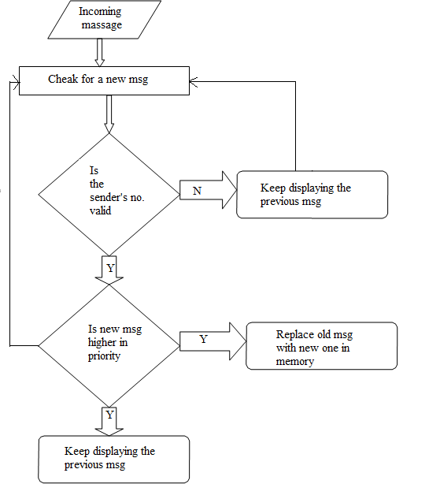
Figure 2.3 Operation flow

2.2.1 Control Flow in Code
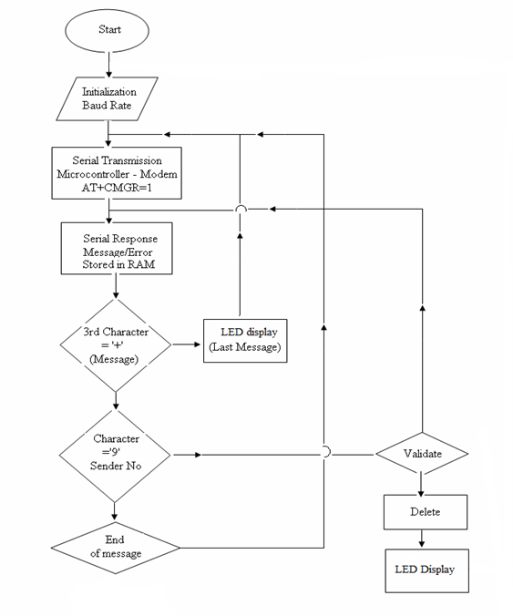
Figure 2.4. Control Flow in Code

2.2.2 Initializations
The baud rate of the modem was set to be 4800 bps using the command AT+IPR=4800.The ECHO from the modem was turned off using the command ATE/ATE0 at the hyper terminal. For serial transmission and reception to be possible both the DTE and DCE should have same operational baud rates. Hence to set the microcontroller at a baud rate of 4800bps, we set terminal count of Timer 1 at 0FFh (clock frequency = 1.8432). The TCON and SCON registers were set accordingly.
2.2.3 Serial transfer using TI and RI flags
After setting the baud rates of the two devices both the devices are now ready to transmit and receive data in form of characters. Transmission is done when TI flag is set and similarly data is known to be received when the Rx flag is set. The microcontroller then sends an AT command to the modem in form of string of characters serially just when the TI flag is set. After reception of a character in the SBUF register of the microcontroller (response of MODEM with the read message in its default format or ERROR message or OK message), the RI flag is set and the received character is moved into the physical memory of the microcontroller.
2.2.4 Validity Check
After serially receiving the characters the code then checks for start of the sender’s number and then compares the number character by character with the valid number pre stored in the memory. Since we are employing just one valid number, we are able to do the validation process dynamically i.e. without storing the new message in another location in the memory. For more than one valid numbers we would require more memory locations to first store the complete (valid/invalid) message in the memory and then perform the comparison procedure.
2.2.5 Display
After validity check the control flow goes into the LED program module to display the valid message stored in the memory. In case of multiple valid numbers all invalid stored messages are deleted by proper branching in the code to the “delete-message” module.

CHAPTER 3
COMPONENTS
3.1 GSM Modem
3.1.1 Description
A GSM modem is a wireless modem that works with a GSM wireless network. A wireless modem behaves like a dial-up modem. The main difference between them is that a dial-up modem sends and receives data through a fixed telephone line while a wireless modem sends and receives data through radio waves. Like a GSM mobile phone, a GSM modem requires a SIM card from a wireless carrier in order to operate. SIM 300 is a Fixed Cellular Terminal (FCT) for data applications.
It is a compact and portable terminal that can satisfy various data communication needs over GSM. It can be connected to a computer and AVR microcontroller kit with the help of a standard RS232C serial port. SIM 300 offers features like Short Message Services (SMS), Data Services (sending and receiving data files), Fax Services and Web Browsing. Remote login and data file transfer are also supported. It is the perfect equipment for factory plants, resorts, dams and construction sites where wired connectivity is not available or not practicable. The SIM 300 is easy to set up. It finds its applications in IT companies, Banks and Financial Institutions, Logistic Companies, Service Providers, Remote Project Sites, Professionals, and such other business establishments. Microcontroller’s uses AT commands to control modems. Both GSM modems and dial-up modems support a common set of standard AT commands. GSM modem can be used just like a dial-up modem. In addition to the standard AT commands, GSM modems support an extended set of AT commands. These extended AT commands are defined in the GSM standards. With the extended AT commands, various things can be done:
- Reading, writing and deleting SMS messages.
- Sending SMS messages.
- Monitoring the signal strength.
- Monitoring the charging status and charge level of the battery.
- Reading, writing and searching phone book entries.
The number of SMS messages that can be processed by a GSM modem per minute is very low -- only about six to ten SMS messages per minute.
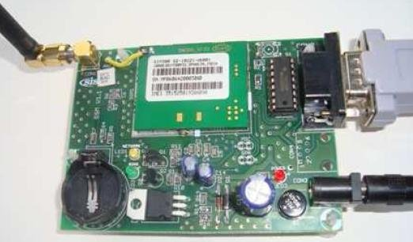

Figure 3.1 SIM300 Module
3.1.2 List of Important AT Commands
After successfully testing the MODEM for its correct operational state, we need to set the MODEM parameters like Baud rate, Echo off etc to enable easier access via a microcontroller which we used in this project. Following is a list of the important AT commands,
- Example: Changing and saving parameters
AT+IPR=2400[Enter] Transfer rate to 2400 bps
AT&W[Enter] save parameters
- Send and Receive
Example: Data transfer
AT+CPIN="xxxx"[Enter] enters PIN
AT+CREG? [Enter] Register Network (0, 1 means logged in)
ATD05111234567 [Enter] Data call
Example: Send SMS with GSM modem / module

- Enter SMS-Center
AT+CSCA=+491722270000[Enter] Enter SMS-Center for Vodafone Germany (T-Mobile
Germany = +491710760000)
Example: Send SMS
AT+CMGF=1[Enter]
AT+CMGS="+491711234567"[Enter]
>Please call office^Z
+CMGF=1 - set modem in text mode
Send SMS (^Z equals StrgZ). At D2 you can
send without international and local code. If you
dial with Int. and local code the transmission
from foreign networks are ensured.
- Example: Receive SMS
A SMS will be stored in the GSM modem / module and being sent via RS232 to the peripherals. The peripherals have to send commands to the GSM unit to receive SMS and to erase SMS from the device in order to free memory.
+CMTI:"SM",x X stands for the memory number of received SMS
AT+CMGR=X[Enter] Read SMS on memory number X
AT+CMGD=X[Enter] Erase SMS on memory number X
ATZ;E[Enter] Echo OFF
ATZ;E1[Enter] Echo ON
AT+COPS?[Enter] Shows if network of SIM-card is available. 0,2,26201= D1 available.
3.2 Microcontroller – ATMEGA16
3.2.1 Description
The Atmel®AVR®ATmega16 is a low-power CMOS 8-bit microcontroller based on the AVR enhanced RISC architecture. By executing powerful instructions in a single clock cycle, the ATmega16 achieves throughputs approaching 1 MIPS per MHz allowing the system designed to optimize power consumption versus processing speed. The device is manufactured using Atmel’s high density nonvolatile memory technology. The On chip ISP Flash allows the program memory to be reprogrammed in-system through an SPI serial interface, by a conventional nonvolatile memory programmer, or by an On-chip Boot program running on the AVR core. The boot program can use any interface to download the application program in the Application Flash memory. Software in the Boot Flash section will continue to run while the Application Flash section is updated, providing true Read-While-Write operation. By combining an 8-bit RISC CPU with In-System Self-Programmable Flash on a monolithic chip, the Atmel ATmega16 is a powerful microcontroller that provides a highly-flexible and cost-effective solution to many embedded control applications.
The Atmel AVR ATmega16 is supported with a full suite of program and system development tools including: C compilers, macro assemblers, program debugger/simulators, in-circuit emulators, and evaluation kits.
3.3.2 Block Diagram of Architecture
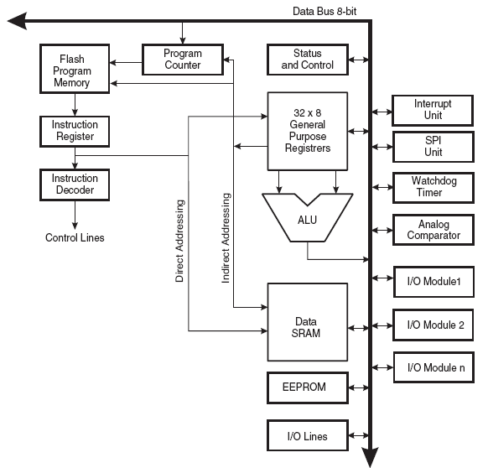
Figure 3.2 Architecture
In order to maximize performance and parallelism, the AVR uses Harvard architecture – with separate memories and buses for program and data. Instructions in the program memory are executed with a single level pipelining. While one instruction is being executed, the next instruction is pre-fetched from the program memory. This concept enables instructions to be executed in every clock cycle. The program memory is In-System Reprogrammable Flash memory.
The fast-access Register File contains 32 × 8-bit general purpose working registers with a single clock cycle access time. This allows single-cycle Arithmetic Logic Unit (ALU) operation. In a typical ALU operation, two operands are output from the Register File, the operation is executed, and the result is stored back in the Register File – in one clock cycle. Six of the 32 registers can be used as three 16-bit indirect addresses register pointers for Data Space addressing – enabling efficient address calculations. One of these address pointers can also be used as an address pointer for look up tables in Flash Program memory. These added function registers are the 16-bit X-, Y-, and Z-register, described later in this section. The ALU supports arithmetic and logic operations between registers or between a constant and a register. Single register operations can also be executed in the ALU. After an arithmetic operation, the Status Register is updated to reflect information about the result of the operation. Program flow is provided by conditional and unconditional jump and call instructions, able to directly address the whole address space. Most AVR instructions have a single 16-bit word format. Every program memory address contains a 16- or 32-bit instruction.
Program Flash memory space is divided in two sections, the Boot program section and the Application Program section. Both sections have dedicated Lock bits for write and read/write protection. The SPM instruction that writes into the Application Flash memory section must reside in the Boot Program section. During interrupts and subroutine calls, the return address Program Counter (PC) is stored on the Stack. The Stack is effectively allocated in the general data SRAM, and consequently the Stack size is only limited by the total SRAM size and the usage of the SRAM. All user programs must initialize the SP in the reset routine (before subroutines or interrupts are executed). The Stack Pointer SP is read/write accessible in the I/O space. The data SRAM can easily be accessed through the five different addressing modes supported in the AVR architecture. The memory spaces in the AVR architecture are all linear and regular memory maps. A flexible interrupt module has its control registers in the I/O space with an additional global interrupt enable bit in the Status Register. All interrupts have a separate interrupt vector in the interrupt vector table. The interrupts have priority in accordance with their interrupt vector position. The lower the interrupt vector address, the higher the priority. The I/O memory space contains 64 addresses for CPU peripheral functions as Control Registers, SPI, and other I/O functions. The I/O Memory can be accessed directly, or as the Data Space locations following those of the Register File, $20 - $5F.
3.2.3 ALU – Arithmetic Logic Unit
The high-performance Atmel ®AVR® ALU operates in direct connection with all the 32 general purpose working registers. Within a single clock cycle, arithmetic operations between general purpose registers or between a register and an immediate are executed. The ALU operations are divided into three main categories – arithmetic, logical, and bit-functions. Some implementations of the architecture also provide a powerful multiplier supporting both signed/unsigned multiplication and fractional format. See the “Instruction Set” section for a detailed description.
3.2.4 PIN DIAGRAM
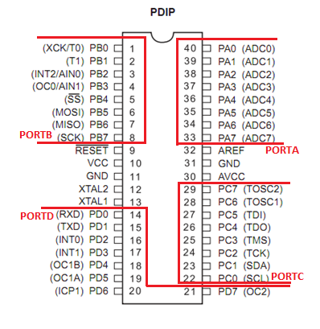
Figure 3.3 Pin diagram (ATMEGA 16)
Pin Descriptions
- VCC = Digital supply voltage.
- GND = Ground.
- Port A (PA7-PA0) = Port A serves as the analog inputs to the A/D Converter. Port A also serves as an 8-bit bi-directional I/O port, if the A/D Converter is not used. Port pins can provide internal pull-up resistors (selected for each bit). The Port A output buffers have symmetrical drive characteristics with both high sink and source capability. When pins PA0 to PA7are used as inputs and are externally pulled low, they will source current if the internal pull-up resistors are activated. The Port A pins are tri-stated when a reset condition becomes active, Even if the clock is not running.
- Port B (PB7-PB0) = Port B is an 8-bit bi-directional I/O port with internal pull-up resistors (selected for each bit). The Port B output buffers have symmetrical drive characteristics with both high sink and source capability. As inputs, Port B pins that are externally pulled low will source current if the pull-up resistors are activated. The Port B pins are tri-stated when a reset condition becomes active, even if the clock is not running.
- Port C (PC7-PC0) = Port C is an 8-bit bi-directional I/O port with internal pull-up resistors (selected for each bit). The Port C output buffers have symmetrical drive characteristics with both high sink and source capability. As inputs, Port C pins that are externally pulled low will source current if the pull-resistors are activated. The Port C pins are tri-stated when a reset condition becomes active, even if the clock is not running. If the JTAG interface is enabled, the pull-up resistors on pinsPC5 (TDI), PC3 (TMS) and PC2 (TCK) will be activated even if a reset occurs.
- Port D (PD7-PD0) = Port D is an 8-bit bi-directional I/O port with internal pull-up resistors (selected for each bit). The Port D output buffers have symmetrical drive characteristics with both high sink and source capability. As inputs, Port D pins that are externally pulled low will source current if the pull-up resistors are activated. The Port D pins are tri-stated when a reset condition becomes active, even if the clock is not running.
- RESET = Reset Input. A low level on this pin for longer than the minimum pulse length will generate a reset, even if the clock is not running
- XTAL1 = Input to the inverting Oscillator amplifier and input to the internal clock operating circuit.
- XTAL2 = Output from the inverting Oscillator amplifier.
- AVCC = AVCC is the supply voltage pin for Port A and the A/D Converter. It should be externally connected to VCC, even if the ADC is not used. If the ADC is used, it should be connected to VCC Through a low-pass filter.
- AREF = AREF is the analog reference pin for the A/D Converter.
    - Features
- High-performance, Low-power Atmel® AVR® 8-bit Microcontroller
- Advanced RISC Architecture
- 131 Powerful Instructions – Most Single-clock Cycle Execution
- 32 x 8 General Purpose Working Registers
- Fully Static Operation
- Up to 16 MIPS Throughput at 16 MHz
- On-chip 2-cycle Multiplier
- High Endurance Non-volatile Memory segments
- 16 Kbytes of In-System Self-programmable Flash program memory
- 512 Bytes EEPROM
- 1 Kbyte Internal SRAM
- Write/Erase Cycles: 10,000 Flash/100,000 EEPROM
- Data retention: 20 years at 85°C/100 years at 25°C(1)
- Optional Boot Code Section with Independent Lock Bits In-System Programming by On-chip Boot Program True Read-While-Write Operation
- Programming Lock for Software Security
- JTAG (IEEE std. 1149.1 Compliant) Interface
- Boundary-scan Capabilities According to the JTAG Standard
- Extensive On-chip Debug Support
- Programming of Flash, EEPROM, Fuses, and Lock Bits through the JTAG Interface
- Peripheral Features
- Two 8-bit Timer/Counters with Separate Prescalers and Compare Modes
- One 16-bit Timer/Counter with Separate Prescaler, Compare Mode, and Capture Mode
- Real Time Counter with Separate Oscillator
- Four PWM Channels
- 8-channel, 10-bit ADC
- 8 Single-ended Channels
- 7 Differential Channels in TQFP Package Only
- 2 Differential Channels with Programmable Gain at 1x, 10x, or 200x
- Byte-oriented Two-wire Serial Interface
- Programmable Serial USART
- Master/Slave SPI Serial Interface
- Programmable Watchdog Timer with Separate On-chip Oscillator
- On-chip Analog Comparator
- Special Microcontroller Features
- Power-on Reset and Programmable Brown-out Detection
- Internal Calibrated RC Oscillator
  - External and Internal Interrupt Sources
  - Six Sleep Modes: Idle, ADC Noise Reduction, Power-save, Power-down, Standby And Extended Standby
- I/O and Packages
  - 32 Programmable I/O Lines
  - 40-pin PDIP, 44-lead TQFP, and 44-pad QFN/MLF
- Operating Voltages
  - 2.7V - 5.5V for ATmega16L
  - 4.5V - 5.5V for ATmega16
- Speed Grades
  - 0 - 8 MHz for ATmega16L
  - 0 - 16 MHz for ATmega16
- Power Consumption @ 1 MHz, 3V, and 25°C for ATmega16L
  - Active: 1.1 mA
  - Idle Mode: 0.35 mA
  - Power-down Mode: < 1 μA.
3.3 Shift register (IC 74HC595)
This IC is used as shift register in the LED matrix. According to shifting pattern the massage is rolling on the led matrix.
3.3.1 Description
The 74HCT595 are high-speed Si-gate CMOS devices and are pin compatible with Low-power Scotty TTL (LSTTL). They are specified in compliance with JEDEC standard No. 7A. The 74HC595; 74HCT595 are 8-stage serial shift registers with a storage register and 3-state outputs. The registers have separate clocks. Data is shifted on the positive-going transitions of the shift register clock input (SHCP). The data in each register is transferred to the storage register on a positive-going transition of the storage register clock input (STCP). If both clocks are connected together, the shift register will always be one clock pulse ahead of the storage register. The shift register has a serial input (DS) and a serial standard output (Q7S) for cascading It is also provided with asynchronous reset (active LOW) for all 8 shift register stages. The storage register has 8 parallel 3-state bus driver outputs. Data in the storage register appears at the output whenever the output enable input (OE) is LOW.
3.3.2 Pin Diagram
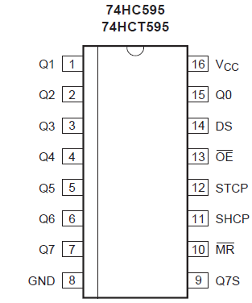
Figure 3.4 Pin diagram of IC 74HC595

3.3.3 Features and Benefit
- 8-bit serial or parallel output
- Storage register with 3-state outputs
- Shift register with direct clear
- 100 MHz (typical) shift out frequency
- ESD protection:
- HBM JESD22-A114F exceeds 2000 V
- MM JESD22-A115-A exceeds 200 V
- Multiple package options
- Specified from 40 degree C to +85 degree C and from 40 degree C to +125 degree C
3.3.4 Application
- Serial-to-parallel data conversion
- Remote control holding register

CHAPTER 4
HARDWARE
4.1 Microcontroller – MODEM Interfacing
4.1.1 DTE and DCE
The terms DTE and DCE are very common in the data communications market. DTE is short for Data Terminal Equipment and DCE stands for Data Communications Equipment. But what do they really mean? As the full DTE name indicates this is a piece of device that ends a communication line, whereas the DCE provides a path for communication. Let's say we have a computer on which wants to communicate with the Internet through a modem and a dial-up connection. To get to the Internet you tell your modem to dial the number of your provider. After your modems has dialed the number, the modem of the provider will answer your call and your will hear a lot of noise. Then it becomes quiet and you see your login prompt or your dialing program tells you the connection is established. Now you have a connection with the server from your provider and you can wander the Internet. In this example you PC is a Data Terminal (DTE). The two modems (yours and that one of your provider) are DCEs, they make the communication between you and your provider possible. But now we have to look at the server of your provider. Is that a DTE or DCE? The answer is a DTE. It ends the communication line between you and the server. When you want to go from your provided server to another place it uses another interface. So DTE and DCE are interfacing dependent. It is e.g. possible that for your connection to the server, the server is a DTE, but that that same server is a DCE for the equipment that it is attached to on the rest of the Net.
4.1.2 RS-232
In telecommunications, RS-232 is a standard for serial binary data signals connecting between a DTE (Data terminal equipment) and a DCE (Data Circuit-terminating Equipment). It is commonly used in computer serial ports. In RS-232, data is sent as a time-series of bits. Both synchronous and asynchronous transmissions are supported by the standard. In addition to the data circuits, the standard defines a number of control circuits used to manage the connection between the DTE and DCE. Each data or control circuit only operates in one direction that is, signaling from a DTE to the attached DCE or the reverse. Since transmit data and receive data are separate circuits, the interface can operate in a full duplex manner, supporting concurrent data flow in both directions. The standard does not define character framing within the data stream, or character encoding.

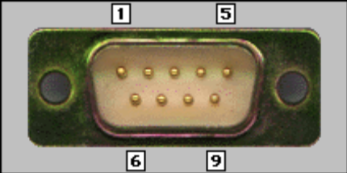
Figure 4.1 RS-232

Table 4.1 Function Signal PIN DTE DCE
Function | Signal | PIN | DTE | DCE
Data | TxD | 3 | Output | Input
Data | RxD | 2 | Input | Output
Handshake | RTS | 7 | Output | Input
Handshake | CTS | 8 | Input | Output
Handshake | DSR | 6 | Input | Output
Handshake | DCD | 1 | Input | Output
Handshake | STR | 4 | Output | Input
Common | Com | 5 | -- | --
Other | RI | 9 | Output | Input

1. Transmitted Data (TxD) = Data sent from DTE to DCE.
2. Received Data (RxD) = Data sent from DCE to DTE.
3. Request to Send (RTS) = Asserted (set to 0) by DTE to prepare DCE to receive data. This may require action on the part of the DCE, e.g. transmitting a carrier or reversing the direction of a half-duplex line.
4. Clear To Send (CTS) =Asserted by DCE to acknowledge RTS and allow DTE to transmit.
5. Data Terminal Ready (DTR) =Asserted by DTE to indicate that it is ready to be connected. If the DCE is a modem, it should go "off hook" when it receives this signal. If this signal is deserted, the modem should respond by immediately hanging up.
6. Data Set Ready (DSR) =Asserted by DCE to indicate an active connection. If DCE is not a modem (e.g. a null-modem cable or other equipment), this signal should be permanently asserted (set to 0), possibly by a jumper to another signal.
7. Carrier Detect (CD) =Asserted by DCE when a connection has been established with remote equipment.
8. Ring Indicator (RI) =Asserted by DCE when it detects a ring signal from the telephone line.
4.1.2.1 RTS/CTS Handshaking
The standard RS-232 use of the RTS and CTS lines is asymmetrical. The DTE asserts RTS to indicate a desire to transmit and the DCE asserts CTS in response to grant permission. This allows for half-duplex modems that disable their transmitters when not required, and must transmit a synchronization preamble to the receiver when they are re-enabled. There is no way for the DTE to indicate that it is unable to accept data from the DCE. A non-standard symmetrical alternative is widely used: CTS indicates permission from the DCE for the DTE to transmit, and RTS indicates permission from the DTE for the DCE to transmit. The "request to transmit" is implicit and continuous. The standard defines RTS/CTS as the signaling protocol for flow control for data transmitted from DTE to DCE. The standard has no provision for flow control in the other direction. In practice, most hardware seems to have repurposed the RTS signal for this function. A minimal “3-wire” RS-232 connection consisting only of transmits data, receives data and ground, and is commonly used when the full facilities of RS-232 are not required. When only flow control is required, the RTS and CTS lines are added in a 5-wire version. In our case it was imperative that we connected the RTS line of the microcontroller (DTE) to ground to enable receipt of bit streams from the modem.
4.1.2.2 Specifying Baud Rate, Parity & Stop bits
Serial communication using RS-232 requires that you specify four parameters: the baud rate of the transmission, the number of data bits encoding a character, the sense of the optional parity bit, and the number of stop bits. Each transmitted character is packaged in a character frame that consists of a single start bit followed by the data bits, the optional parity bit, and the stop bit or bits. A typical character frame encoding the letter "m" is shown here.

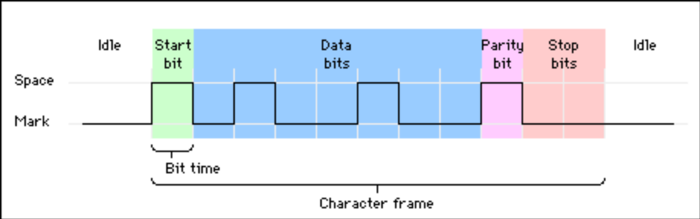

Figure 4.2 Characters Frame Encoding ‘m’
We specified the parameters as baud rate – 4800 bps, 8 data bits, no parity, and 1 stop bit (4800-8-N-1).
DCE Baud Rates:
110,300,1200,2400,4800,9600,19200,38400,57600,115200,230400,460800,921600
(Possible Baud Rates)
4.2 LED DISPLAY
Light-emitting diodes (LEDs) provide a cheap and convenient way to display information electronically. LEDs are tiny light sources that are illuminated solely by the movement of electrons in semiconducting materials. They emit light when forward-biased, fit easily into an electrical circuit, and are durable. LEDs are often arranged in patterns to display information. The seven-segment configuration of an LED arranged in the form of the digit 8 can be restrictive in that it does not adequately allow the display of some alphanumeric characters. By contrast, the versatility of a matrix arrangement allows an LED unit to display complicated shapes.
4.2.1 LED Matrix Construction
Based on the electrode connections, two types of LED matrices are explained below:
- An LED matrix with a common anode for LEDs in a row—when a row of LEDs feature a common anode, the LEDs in each column must include a common cathode.
- An LED matrix with a common cathode for LEDs in a row—when a row of LEDs feature a Common cathode, the LEDs in each column must include a common anode.
Figure displays a matrix construction of the common anode type. A single matrix is formed by thirty-five LEDs arranged in five columns and seven rows (5x7). The anodes of the five LEDs forming one row are connected together. Similarly, the cathodes of the seven LEDs of a column are connected together. In this arrangement of LEDs, the cathodes are switched to turn the LEDs of a row ON or OFF.
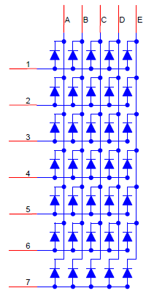
Figure 4.3. LED Matrix with Common Anode

Figure shows displays the matrix (unit) which can be used to display a single alphanumeric character. Several such units can be placed next to each other to form a larger panel to display a string of characters.
4.2.2 LED Matrix Layout
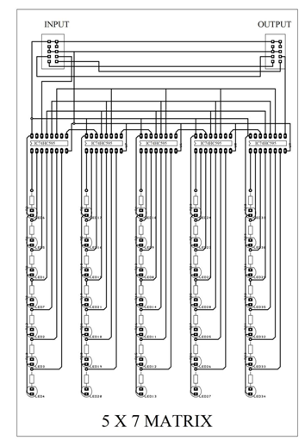
Figure 4.4 Layout of 5*7 matrix
4.3 Microcontroller-LED interfacing
For a 5x7 LED matrix, it is impractical to assign one pin per LED, as a four-unit, 5x7 matrix requires 35x4=140 pins. Such a display scheme can cause higher power dissipation and is not easily scalable. Multiplexing can be used to reduce the number of GPIO pins, with only a small increase in the amount of external hardware, such as latches. Each row of the LED is driven for a brief period before switching to the next row. Because of a visual phenomenon termed persistence of vision1, rapid switching between rows produces the illusion that all of the rows are ON at the same time. To function as intended, the two additional requirements must be met are:
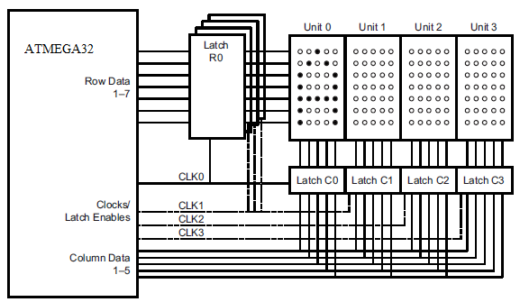
Figure 4.5 Microcontroller-LED interfacing
1. The LEDs must be overdriven proportionately or they can appear dim. The dimness occurs because a row is ON for only a fraction of time.
2. The rows must be updated often enough (for example, each row is scanned about 30–40 Times per second), to avoid display flicker. For actual character display, it is necessary to map the shape of the character to the 5x7 LED matrix. Figure 4.6.2 displays the characters A and B. For any Given character, a corresponding pattern of LED ON and LED OFF must be generated and stored in Memory and must be used to display the character at run time. For example, the character A, as
Displayed in Figure 4.6.2, is formed with the pattern shown in Table 1.
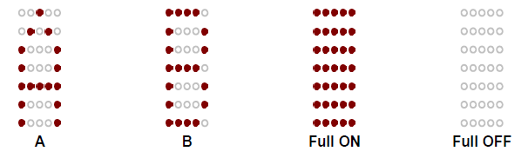
Figure 4.6 Illustrations of the Characters A and B
Other characters/objects can be developed in a similar manner and stored in memory to be used while displaying. By frequently switching the rows or columns with the proper selection of LED ON/OFF patterns, the human eye perceives the display as continuous.
Table 4.2 Display Pattern for the Character A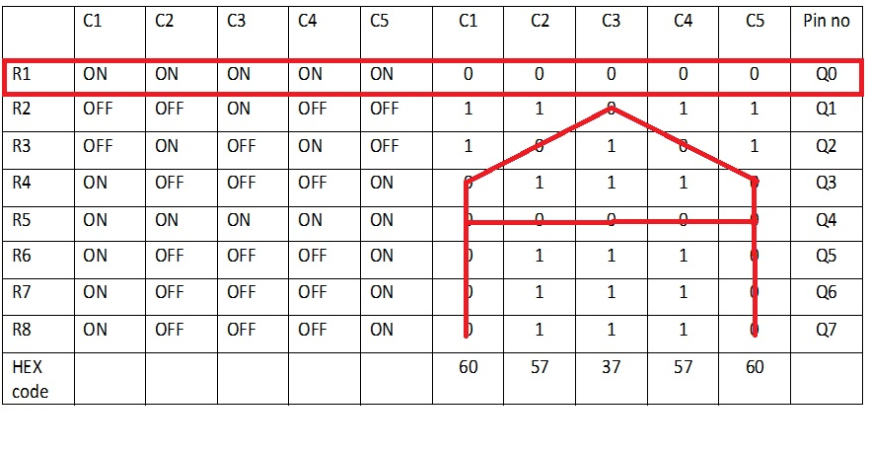

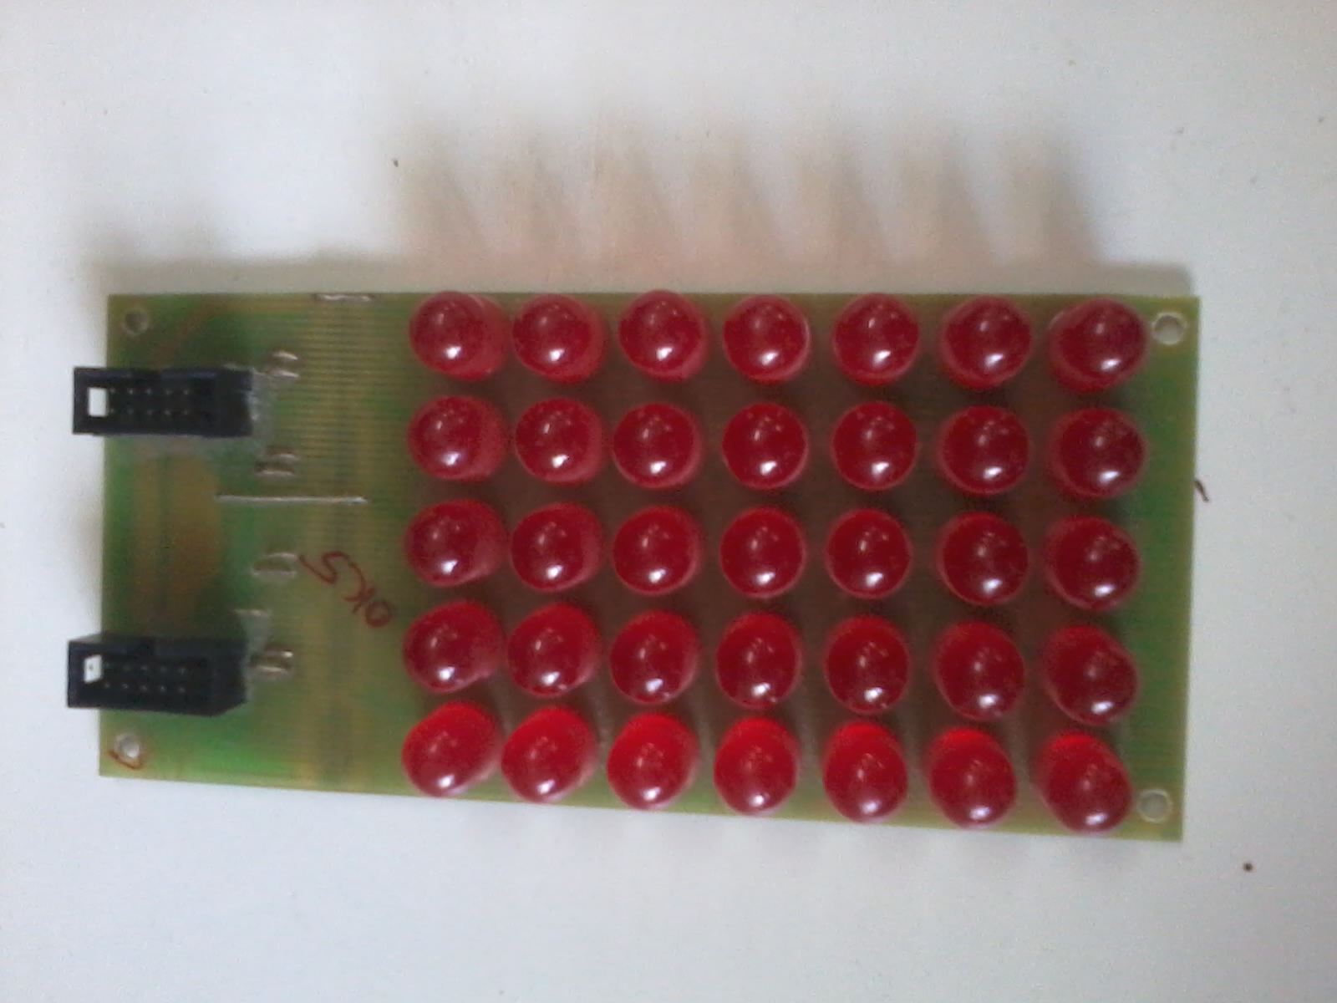
Figure 4.7 LED panel

CHAPTER 5
SOFTWARE
5.1 Eagle (Easily Applicable Graphical Layout Editor)
The EAGLE software is a user friendly, powerful and affordable solution for PCB design including Schematic Capture, Board Layout, and AutoRoute which offers a powerful environment to create electrical layouts and schematics on Windows, Mac or Linux.
This for several times awarded software offers an entire synchronization between the layout editor and the schematic editor. Any changes to the layout or schematic will automatically take over to the other editor without need for an additional user interaction. With up to 999 sheets in one schematic and a maximum layout size of 64" × 64" you are able to realize circuits and layouts in nearly any arbitrarily kind. The resolution of one 10 thousandth millimeter and up to 16 signal layer permits the production of very complex boards. In spite of the extensive possibilities EAGLE is easy to use and impresses with lighting fast response times. EAGLE contains unlimited undo/redo and validates the layouts and schematics automatically and generates error messages on the fly.
We are able to offer an EAGLE version that optimally fits your needs. You can choose between the Light, Standard and Professional Variation of EAGLE and the modules layout, Schematic and auto router can be ordered individually or in combination.
- General
- Online Forward-und-Back-Annotation
- Context sensitive help function
- No Hardware-Copy Protection
- Multiple windows for board, schematic and library
- Powerful User Language
- Integrated text editor
- Available for Windows, Mac and Linux
- Layout-Editor
- Maximum drawing area 1.6 × 1.6 m (64" × 64")
- Resolution 1/10,000 mm (0.1 micron)
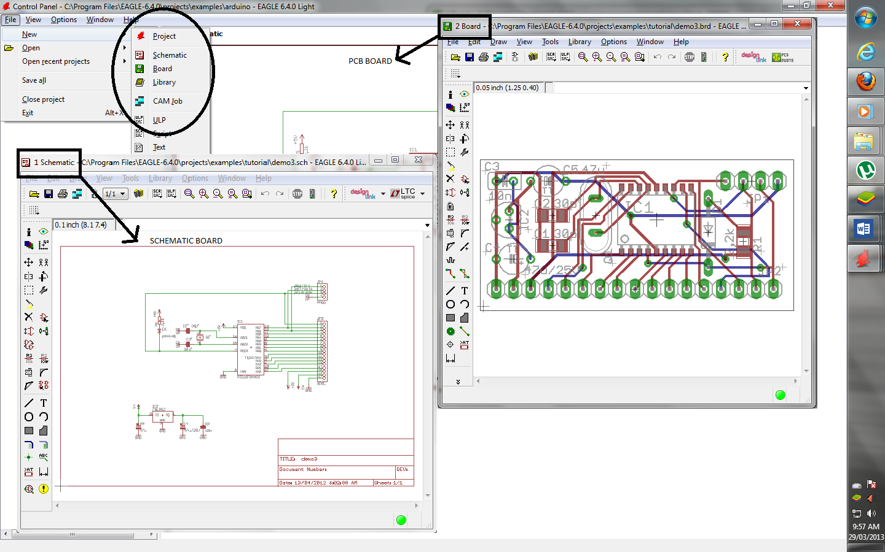
Figure 5.1 Eagle software
- Up to 16 signal layers
- Conventional and SMT parts
- Comes with a full set of part libraries
- Interactive Follow-me Router (requires the AutoRoute module)
- Easily create your own parts with the fully integrated library editor
- Undo/redo function for ANY editing command, to any depth
- Script files for batch command execution
- Copper pouring
- Cut and paste function for copying entire sections of a drawing
- Design rule check
- Schematic Editor
- Up to 999 sheets in one schematic
- Electrical rule check
- Gate and pin swap
- Create a board from a schematic with a single command
- AutoRoute
- Rip up & retry router
- Up to 16 signal layers
- Routing strategy driven by user definable cost factors
- CAM-Processor
- Postscript
- Pen plotters
- Gerber plotters
- Excellon and Sieb & Meyer drill files
- Configurable through ASCII file for easy definition of your own output devices
5.2 Programming (programming notepad)
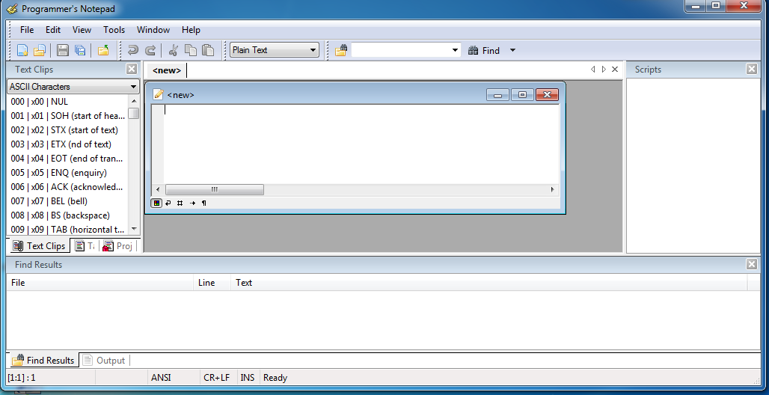
Figure 5.2 programming notepad
It provides following features
- Syntax Highlighting for lots of languages, configured with schemes
- Multi-language user interface
- Unlimited number of schemes supported, powerful syntax
highlighting supporting both user-defined and built-in schemes
- Text Clips provide smart templates for text insertion
- Code Folding/Outlining
- Docking windows for: File Browser, Open Files, Text Clips, Tool Output, Find in Files results
- Regular expression search and replace (full Perl syntax)
- Excellent external tool support with user-configurable output matching.
- click on errors and warnings to jump right to the place in the file where they were generated
- Split Views
- Bookmarks (both numbered and plain)
- Export to HTML (using CSS) and RTF
- Code definition browsing and navigation (using Tags)
- Non fixed-width font support
- Projects and Project Groups with multi-level folders and file system mirroring
- Scripting with Python
- Extensions support for developing add-ons with C++
- Support for UTF8, 16 and various file encodings
- Support for windows, Unix and Macintosh line endings
- Tabbed MDI interface, with multi-level split views
- Word-wrapping

CHAPTER 6
PRINTED CIRCUIT BOARD
We have used the advanced circuit’s software PCB artist for the PCB designing. This Software allows us to access the entire library which contains the huge range of DIP, SIP & SMD IC.
6.1. PCB Fabrication
The fabrication of a PCB basically of four steps.
a) Preparing the PCB pattern.
b) Transferring the pattern onto the PCB.
c) Developing the PCB.
d) Finishing
e) Drilling, cutting, smoothing, turning etc.
f) Soldering
g) Assembling
a) Preparing PCB Patterns
Pattern designing is the primary step in fabricating a PCB in this step, all interconnection between the components in the given circuit are converted into PCB tracks several factors such as positioning, the diameter of holes, the area that each component would occupy, and the type of end terminal should be considered. For this we have used EGALE software.
b) Transferring the PCB Pattern
The copper side of the PCB should be thoroughly cleaned with the help of alcoholic spirit or FeCl3 must be completely free from dust and other contaminants. The mirror image of the pattern must be carbon copied and to the laminate the complete pattern may now be made each resistant with the help of paint and thin brush.

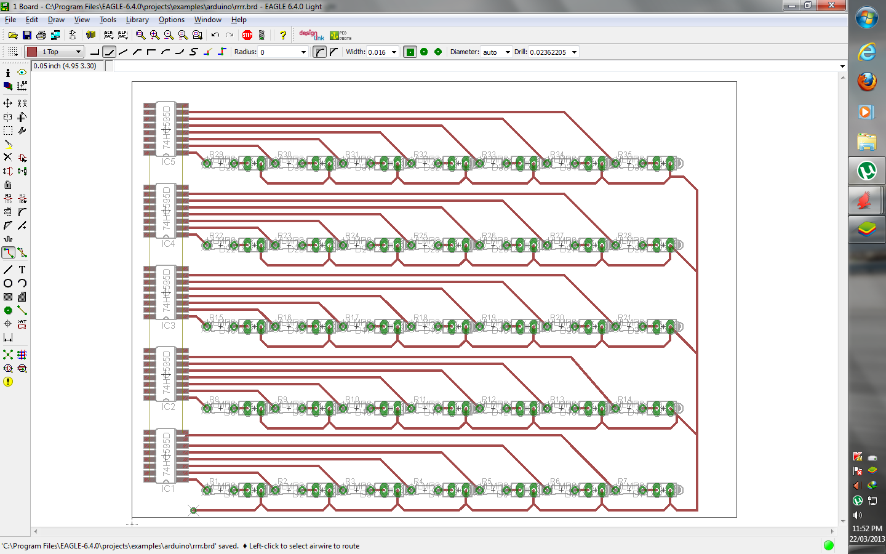
Figure 6.1 Eagle window
This window shows the application to design a pcb in Eagle software.

c) Development
In this developing all excessive copper is removed from the board and only the printed pattern is left behind. About 100ml of tape water should be heated to 75 ° C and 30.5 grams of FeCl₃ added to it, the mixture should be thoroughly stirred and a few drops of HCL may be added to speed up the process. The board with its copper side facing upward should be placed in a flat bottomed plastic tray and the aqueous solution of FeCl₃ poured in the etching process would take 40 to 60 min to complete. After etching the board it should be washed under running water and then against light .the printed pattern should be clearly visible. The paint should be removed with the help of thinner.
d) Finishing Touches
After the etching is completed, hole of suitable diameter should be drilled, then the PCB may be tin plated using an ordinary 35 Watts soldering rod along with the solder core, the copper side may be given a coat of varnish to prevent oxidation.

e) Drilling
Drills for PCB use usually come with either a set of collects of various sizes or a 3-Jaw chuck. For accuracy however 3-jaw chunks aren’t brilliant and small drill below 1 mm from grooves in the jaws preventing good grips.
f) Soldering
Begin the construction by soldering the resistors followed by the capacitors and the LEDs diodes and IC sockets. Don’t try soldering an IC directly unless you trust your skill in soldering. All components should be soldered as shown in the figure. Now connect the switch and then solder/screw if on the PCB using multiple washers or spaces. Soldering it directly will only reduce its height above other components and hamper in its easy fixation in the cabinet. Now connect the battery lead.

CHAPTER 7
RESULT OF DESIGN
7.1 Advantages
- It is a wireless transmission system which has very less errors and maintenance.
- It is cost efficient system and very easy to handle.
- Alphanumeric LCDs have a limitation on size as well as no of characters. These can be replaced with large LED display characters. These can be replaced with large LED display boards.
- Secured data transfer.
- Avoids time wasted on setup problems.
- It avoids use of PC interface to configure any message.
7.2 Applications
- In restaurants wherein the order and special discounts can be displayed at all branches simultaneously.
- In colleges where in students and staff can be informed simultaneously in on time.
- It can be set up at public transport places like railways, bus station and airport in emergency situations.
- Used in Cities, Malls, Theaters for Advertisement purpose.
7.3 Implementation and future scope
7.3.1 Overview
Information sharing holds an important role in development of our institute. The current means of information transfer are notice and circulars. New notice or circular is only checked at the end of the day. This makes the process very time consuming and inefficient. Looking into current trend of information transfer in the campus, it is seen that important notice take time to be displayed in the notice boards. This latency is not expected in most of the cases and must be avoided.

7.3.2 Proposal
It is proposed to implement this project at the institute level. It is proposed to place display boards at major access points. These include canteens, entrance gate, hostel area etc. The proposed locations of these display boards are shown in the figure. But, the electronics displays which are currently used are programmable displays which need to be reprogrammed each time a new notice comes. The process of reprogramming includes burning the microcontroller again and again. This makes it inefficient for immediate information transfer, and thus the display board loses its importance. The GSM based display Notice Board can be used as add-on to these display boards and make it truly wireless. The display board programs itself with the help of the incoming SMS with proper validation. The valid senders may include the Director, Deans and Registrars. The centralized system can be placed as the Computer Center for access by any other valid users with authentications. SMS from these users is treated to be valid and is displayed. Other SMS from any other mobile phone is discarded. Thus information from valid sources can be broadcasted easily.
Such a system proves to be helpful for immediate information transfer and can be easily implemented at the institute level.

CHAPTER 8
CONCLUSION
As the GSM industry is becoming the prime growth of telecom industry the project can be used everywhere easily. Also with the help of GSM technology it can be accessible easily, even from other countries. The market potential for this kind of project is also vast and growing. The use of digital notice board is more preferred. The project also offers security and the content cannot be manipulated. The low cost requirement of the project also helps to use it at a large scale. The prototype of the GSM based Notice Board was efficiently designed. This prototype has facilities to be integrated with a display board thus making it truly mobile. The Notice Board accepts the SMS, stores it, validates it and then displays it in the LED module. The SMS is deleted from the SIM each time it is read, thus making room for the next SMS. The prototype can be implemented using commercial display boards. In this case, it can solve the problem of instant information transfer in the campus.

References
[1] J.D. Gibson(Ed), “The Mobile Communications Handbook.” 2nd Ed, CRC Press Ltd., USA, 1999.
[2] L.Harte, R.Levine and G.Livingston, “GSM Superphones.” McGraw Hill, New York, pp 105-116, 1999.
[3] R.A. Steuernagel, “The Cellular Connection, A Guide to Cellular Telephones.” John Wiley, New York, 2000.
[4] C.Y.Lee, “Mobile Cellular Telecommunications Analog and Digital Systems.” 2nd Ed., McGraw Hill, Lisbon, 1995.
[5] M, Janes,”Microcontroller Cookbook”, Newnes, 1997.
[6] Embedded by Yashvant Kanitkar. SIM300 GSM MODEM Manual

Appendix

Global System for Mobile Communication (GSM)
Global system for mobile communication (GSM) is a globally accepted standard for digital cellular communication.
GSM Network
GSM provides recommendations, not requirements. The GSM specifications define the functions and interface requirements in detail but do not address the hardware. The reason for this is to limit the designers as little as possible but still to make it possible for the operators to buy equipment from different suppliers. The GSM network is divided into three major systems: the switching system (SS), the base station system (BSS), and the operation and support system (OSS).

